WEATHER FORECAST APPLICATION

Intern Details
Name: Shaik.Nousheen sunaina
Internship Domain: Python Programming
Project Title: Weather Forecast Application

Introduction
The Weather Forecast Application is a Python-based desktop application developed using Tkinter. It allows users to search for weather information of any city and displays real-time weather details using a weather API. The application provides an easy-to-use graphical interface for viewing weather conditions.

Objectives
- To develop a user-friendly weather application.
- To learn API integration in Python.
- To understand GUI development using Tkinter.
- To display real-time weather information for any city.

Modules Used
- Python
- Tkinter
- Requests
- Pillow (PIL)
- Datetime
- OpenWeatherMap API

Features
- Search weather by city name.
- Display temperature in Celsius.
- Show weather condition.
- Display humidity and wind speed.
- Show feels-like temperature.
- Search history support.
- Refresh weather data.
- Dark/Light mode option.
- Error handling for invalid city names.

Working of the Project
1. User enters a city name.
2. The application sends a request to the weather API.
3. Weather data is fetched in real time.
4. The application displays temperature, humidity, wind speed, and weather conditions.
5. Search history is stored for future reference.

Output Screenshots
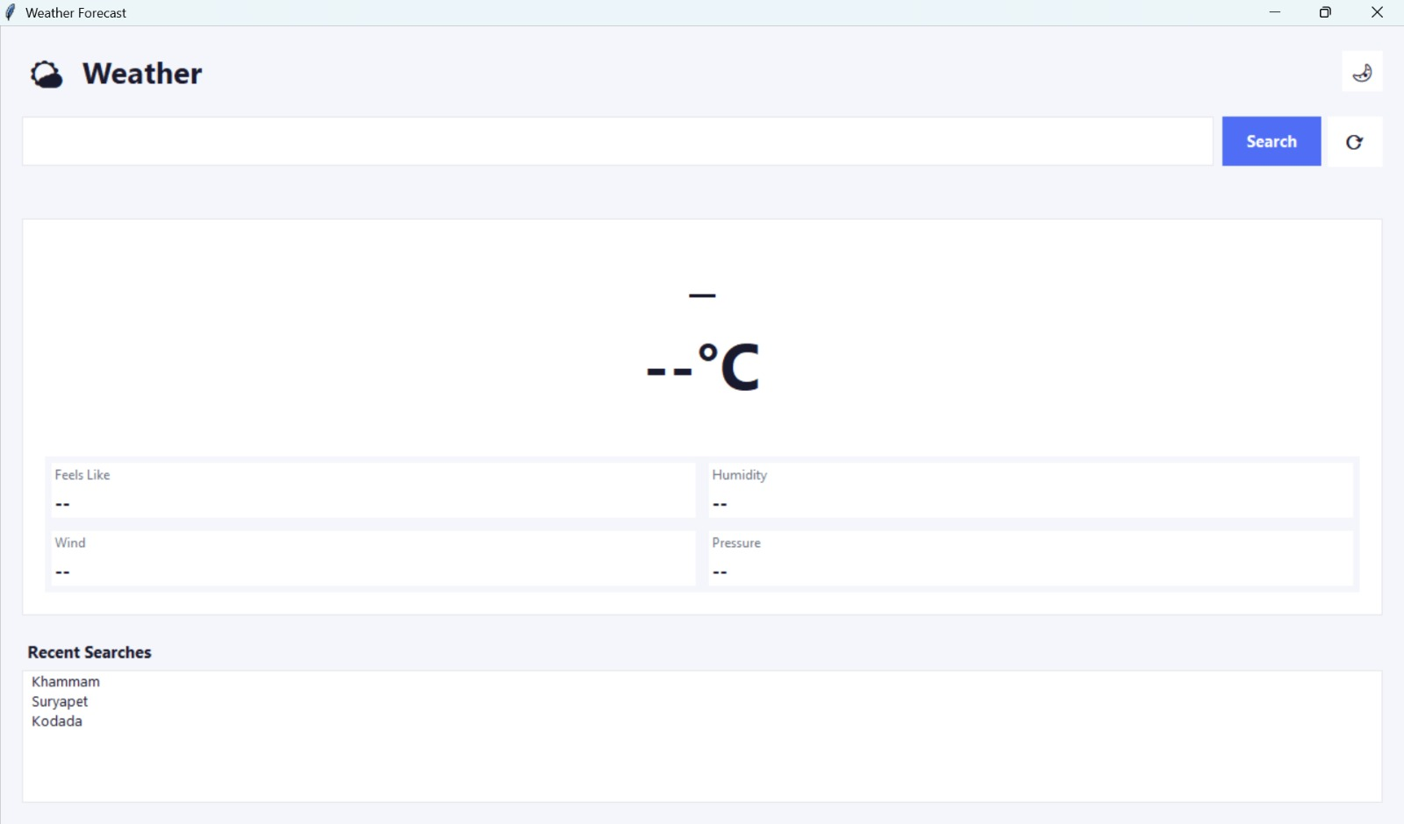
Fig1:main screen
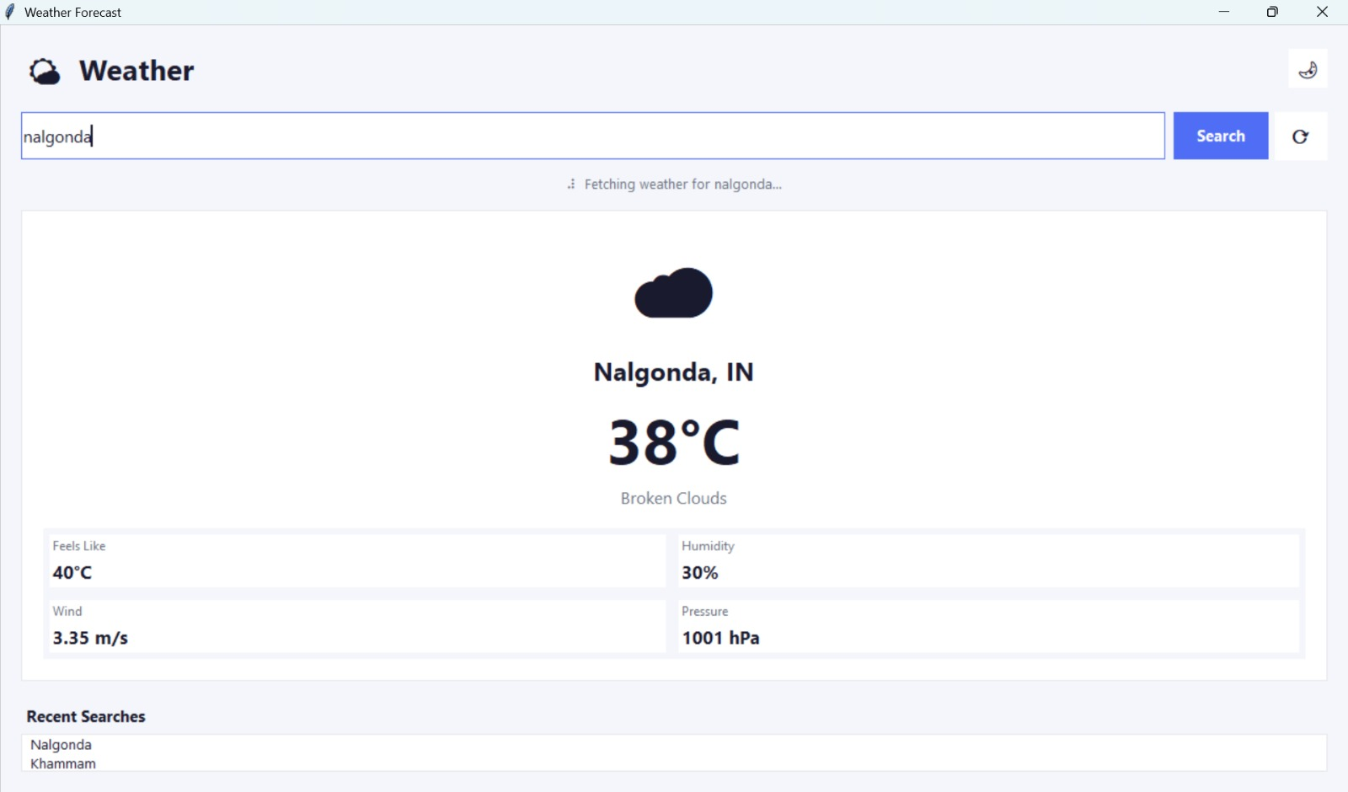
Fig2:Fetching weather
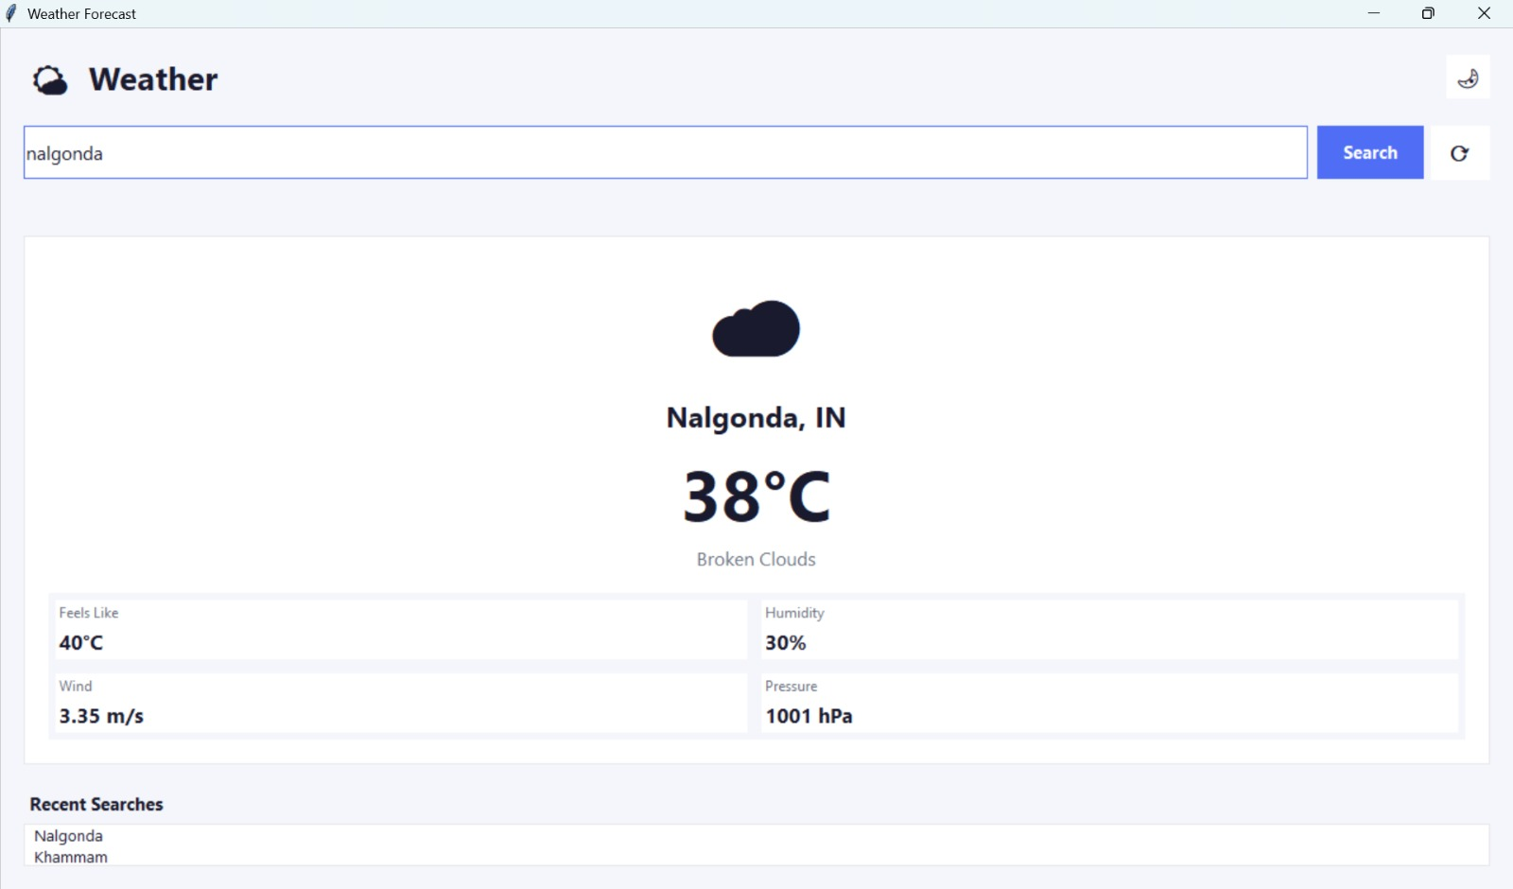
Fig3:Weather deatils
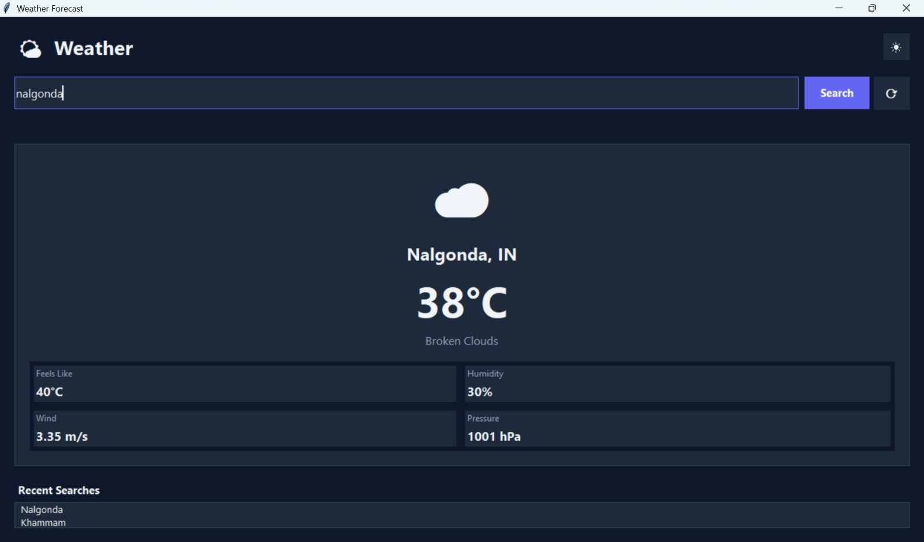
Fig4:Dark mode

Future Enhancements
- Add 7-day weather forecast.
- Add location detection using GPS.
- Add weather alerts and notifications.
- Improve user interface with advanced themes.

Conclusion
The Weather Forecast Application successfully provides real-time weather information through a simple and attractive graphical interface. This project helped in understanding Python GUI development, API integration, and exception handling.

